Practical work : Page with password

**Evaluated skills :**

*→ PHP*

***Introduction :***

As a rule, you should have read all the chapters before the practical work to understand it. Here is the list of knowledge you will need to complete this lab:

display text with echo;

use the variables (assignment, display ...);

transmit variables via a input of a form;

use simple conditions (if, else).

If one of these points is a little vague for you (you may have forgotten), do not hesitate to re-read the corresponding chapter, you will need it to properly handle the practical work. You will see, you will not be asked to do complicated things. The goal is simply to assemble all your knowledge to answer a specific problem.

**Presentation of the exercise :**

Here's the scenario: you want to put a web page online to give confidential information to certain people. However, to limit access to this page, you will need to know a password.

In our case, the confidential data will be the access codes to NASA's central server (let's be crazy!). The password to view access codes will be kangaroo.

Can you make a page that only displays these secret codes if you have entered the correct password?

**How to start ?**

To code correctly, I always recommend working first on draft (you know, with a pen and a sheet of paper!). It can often seem like a waste of time, but it's quite the opposite. If you start writing lines of code as you go along, it's sure to be a bazaar. On the other hand, if you take five minutes to think about it in front of a sheet of paper, your code will be better structured and you will avoid many mistakes (which make them waste time).

What should we think about our draft?

To the problem that you ask yourself (what do I want to do?).

In the diagram of the code, that is to say that you will start to cut it into several pieces, themselves cut into small pieces (it is easier to swallow).

The PHP functions and knowledge you will need (to make sure you use them properly).

And to show the example, we will follow this list for our practical work.

**Problem**

We must protect the access to a page by a password. The page should not be displayed if you do not have the password.

**Code diagram**

For the user to enter the password, the easiest way is to create a form. He will call the protected page and send him the password.

Access to the content of the page will only be allowed if the password provided by the user is kangaroo.

You must therefore create two web pages:

form.php: contains a simple form as you know how to do it;

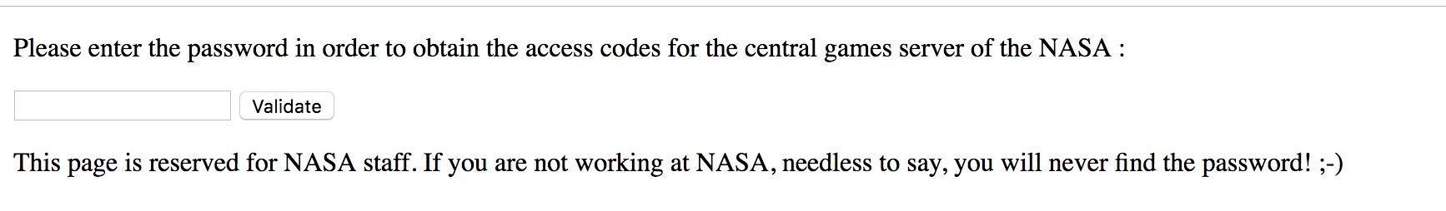

secret.php: contains the "secret codes" but only displays them if the correct password is given.

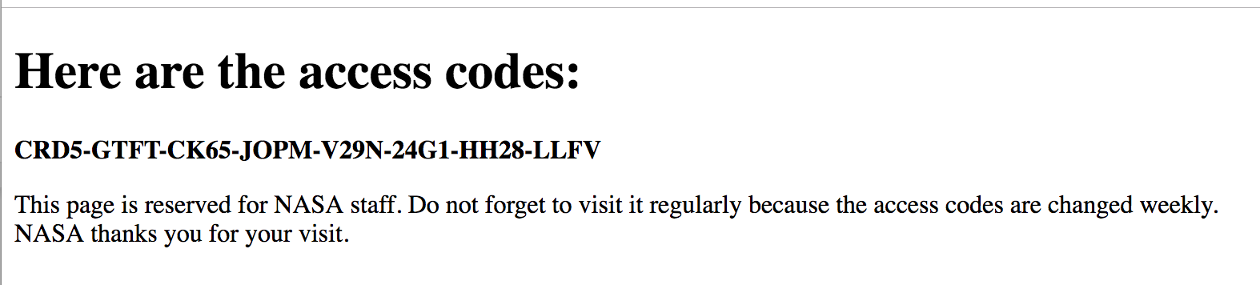

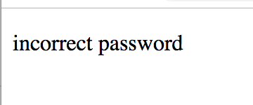

**Going Further Exercise :**

If you wish, know that it is possible to do this practical work in one page instead of two.

Imagine that the form, on the form page.php, is called itself. Clearly, the action attribute of the form would be action = "form.php". This would mean that the data would be sent on the same page.

In this mode of operation, the page form.php would contain both the form and the secret message.

How can we do that? It is not dangerous ? It would not be very secure, if?

We can do this very securely, it's just a bit harder to imagine.

You have to build the code of your form.php page in two big parts:

if no password has been sent (or if it is false): display the form;

if the password has been sent and it is good: display the secret codes.

So your whole PHP page will be built around a big one that might look something like this:

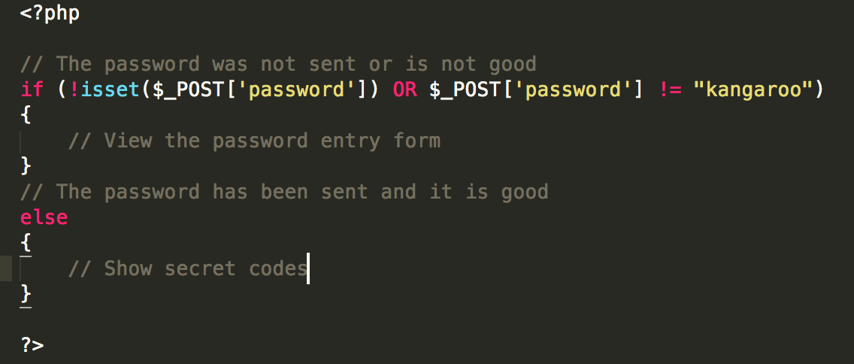

That's basically how we would do it. Whenever the form.php page is called, it determines (through the if) whether it is called to display the secret part or if it is called to display the password entry form.

Here is what will happen:

1 - The first time the visitor loads the page form.php, no POST data is sent to the page. This is the form that appears.

2 - Once you have sent the form, the form page.php is reloaded and this time it receives the POST data just sent. It can therefore analyze them and, if the password is good, it displays the secret codes.